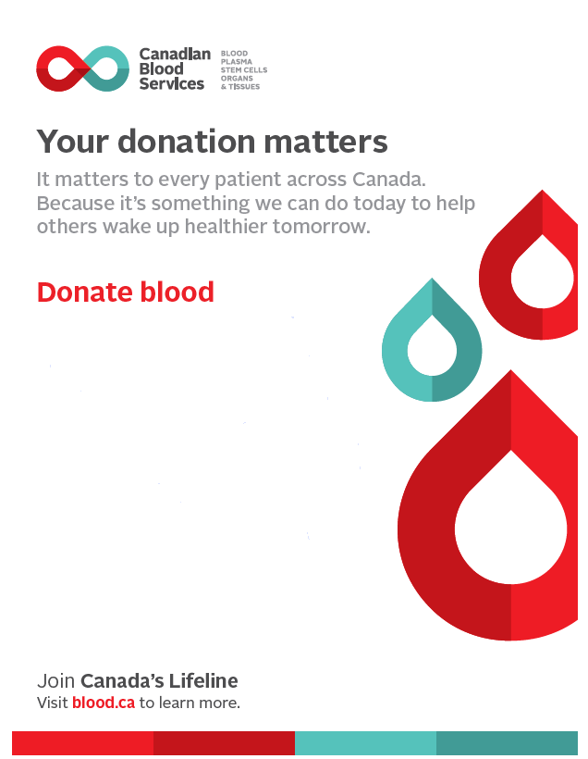

Ladysmith

Blood Donation Event

**June 1, 2022**

(Wednesday)

12:00 p.m. to 6:45 p.m.

**Bethel Church**

1149-4 Avenue

Scan QR code to book appointment:

|  |  |
| --- | --- |
|  |  |
|  |  |
|  |  |

Please check blood.ca or Giveblood app to book an appointment.  Donors who have current appointment will be contacted with the new site location.