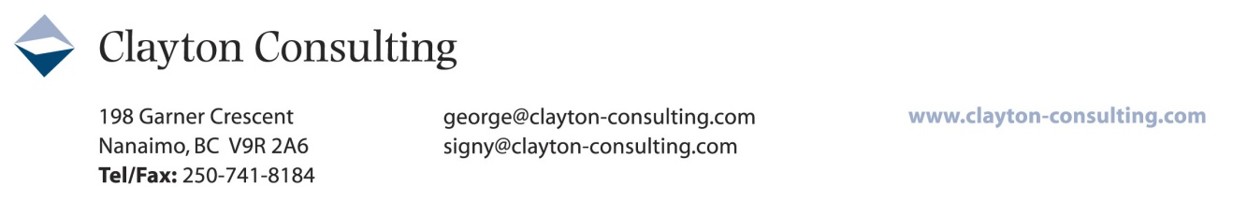
Meeting #5: January 27, 2016 Round Table Report – Ladysmith Chamber of Commerce – Following the work of those gathered on September 23, 2015 to review the 57 ‘Actions’ identified in the ‘Town of Ladysmith 2008-2012 Economic Development Strategic Plan and who developed a shortlist of 4 priority actions, another small group met to begin the process of identifying detailed steps required in order to effectively pursue these four actions.
These four Priority Actions, along with the basic steps identified at the January meeting are captured below. (For efficiency, given that Priority Action #3 is already committed in principle, the volunteers gathered chose to focus only on Priority Actions #1 and #4:
Priority Action Short List:
- Recruit a Major Attraction and/or Hotel (G2:01:PG3)
  - Background Thinking – prospective visitors need reasons to stay as well as places to stay. Which comes first may be more circumstantial than strategic. Both are desired.
    - Have a Chamber committee develop a strategic action plan to bring a music & arts focus;
    - Use/develop the water side of the highway for a music & arts centre – funky, old-fashioned workshop/performance space – Expos legacy building might be a starting place;
    - Identify available land and create a business plan which might include studio space to provide a core business ‘anchor’;
    - Sell concepts to City Council identifying barriers needing attention and work required to move community forward—welcoming business and development;
    - Develop a feasibility plan for a project with mid-Island reach – perhaps also attracting film industry;
      - This might be a school that teaches art, music, film and attracts teachers, students, performers, festivals, etc.
    - Find partners – e.g. VIU, to program (little arts campus) – perhaps a VIU satellite;
    - Include shops, food & beverage amenities in the centre;
    - Develop or improve accessibility via walkway crossing the highway or via existing tunnel;
- Cost of Doing Business Research (G3:04:PG2)
  - Background Thinking – This emerged as a priority from items 5,6,7 & 8 in the list of 16 priorities (above) because the volunteers recognized that this research would be the first step needed to then proceed with the other three ‘Actions’identifed.
- Resident/Business BRE Survey (‘Business Walk’) (G1:01:PG1)
  - Background Thinking – This is ‘low hanging fruit’ because the Chamber and City are already committed to the Business Walk process.
    - Recruit volunteers and engage City Council;
    - Schedule for October (‘Small Business Month’) or don’t wait and conduct the survey this Spring.
- Tourism Product Development and Packaging (G1:03:PG2)
  - Background Thinking – The volunteers felt that the community needs a ‘hook’ and that effective packaging of what already exists and developing more product to complement was most important so that the community has something tangible to market/sell.
    - Take an inventory of existing tourism product offerings;
    - Identify target markets – At what cost? What resources are available?
    - Explore accommodation partnerships – e.g. Ladysmith B&Bs, Nanaimo and Victoria hotels;
    - Develop a budget and find funding to get started – co-op of operators, government/municipal seed funding;
    - B&Bs already work together. Develop an attraction pamphlet to distribute with B&Bs;
    - Develop a calendar of events and post of Chamber website. Broadcast the existence of the calendar and encourage links from City, operators, B&Bs, etc.
Worth Noting:
- “We’re competing with lots of pretty places. We need an attraction and a way to stay overnight.” Those gathered in January noted that the logical and practical place to start would be to strengthen collective capacity to package and market attractions that already exist while also engaging related businesses such as B&Bs to participate in ‘selling’ the community.
- “More information is needed regarding the actual benefit of film location business. The anecdotal feedback from merchants is that filming downtown is NOT good for business.”
- “The Strategic Plan assumes the existence of an Economic Development Commission. Do we need to revisit this? Some of the proposed ‘Actions’ in the Plan are too far down the road; some are already being pursued by the City; some would require the hiring of consultants for which we may not be ready. Where will resources come from to enable economic development.”

